Worksheet


Items highlighted in yellow are tasks for you to complete
Items in Blue italics are help tips

Foam, Material and Metal Graphic Design Y9

Using pieces of media like foam, metal, sponges, or any media you can think of, create designs using your own creativity each slide should be a double spread, two alternative pictures on one board.

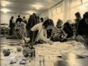
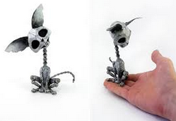

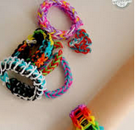

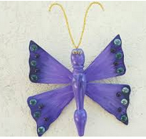


Need help just ask

